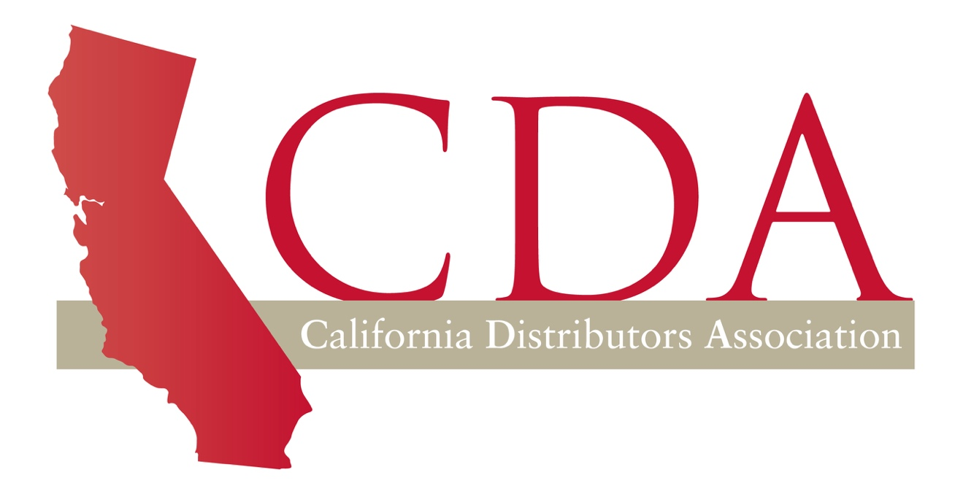2026 CONVENTION
SPONSORSHIP

Monday October 19th – Wednesday, October 22nd

Company ________________________________________________________

Address _________________________________________________________

City _____________________________ State _______ Zip Code _________

Telephone Number ________________________________________________

Sponsorship Approved by ___________________________________________

2026 Sponsorship.…………………………………………….. $

Thank you very much for your consideration and continued support!

Please forward the completed form to cda@lobbycal.com, and an invoice will be issued shortly.

Alternatively, send in the completed form and payment to:

California Distributors Association
1215 K Street, Suite 1830
Sacramento, CA 95814

